Cara Print SOP

By

Rolando Manso

This SOP is meant only for those who have been previously trained by proficient members of TSD’s CAM team.

*For Tray and Wax Rim information,* *please skip to section 2* *if you have already been trained.* *Post processing info can be found here**.*

Open Cara nesting software to begin.

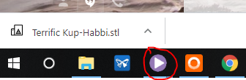

This opens the print manager.

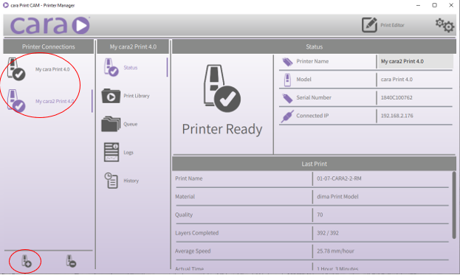

It may be necessary to connect to the printers if they are not visible in the upper left-hand corner. We connect by clicking on the plus sign in the bottom left hand corner. The IP address from the printer will be required for connection (192.168.2.175 & 192.168.2.176). Please refer to your training.

Click the print editor symbol in the top right-hand corner of the screen.

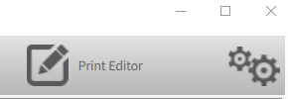This brings up the print editor.

Click the “Add” button to nest STL files.

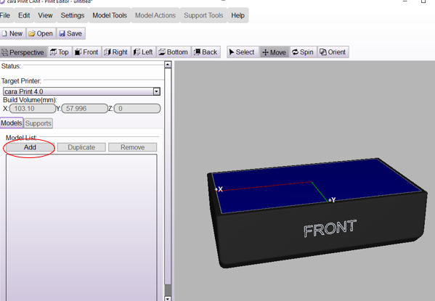

Choose the appropriate files.

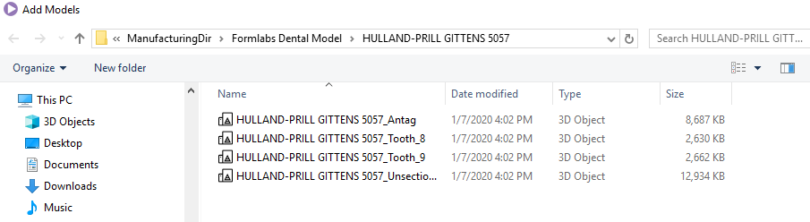

*Solid = unsectioned (sic) model – Full & Quad = all files – always print all dies*

Click on the “Supports” tab and then the “Support Tool” to add supports to the model.

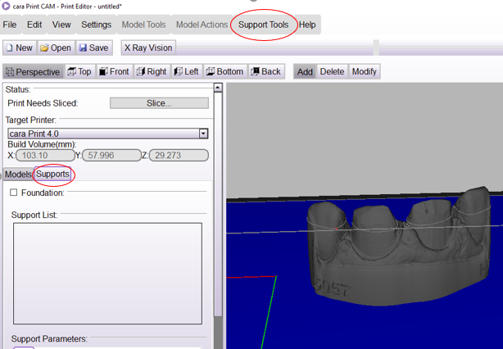

Click on “Automatic Supports”.

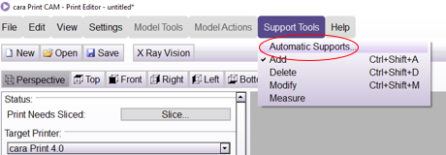

Verify support density is 50% and click “Generate Now”.

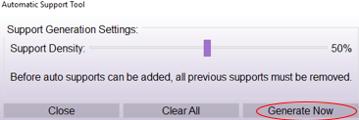

Inspect your model for stray supports and delete them via right click and delete support.

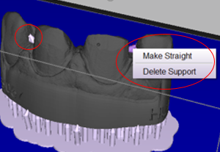**\*\*\*No supports may be on margins\*\*\***

Save per the proper naming convention as trained.

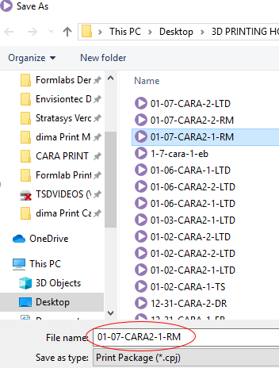

Upon successful save, slice the model by clicking slice.

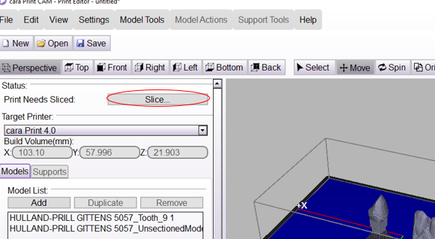

Upon completion of the slicing process, upload the prints to the appropriate printer by clicking “Upload to printer”.

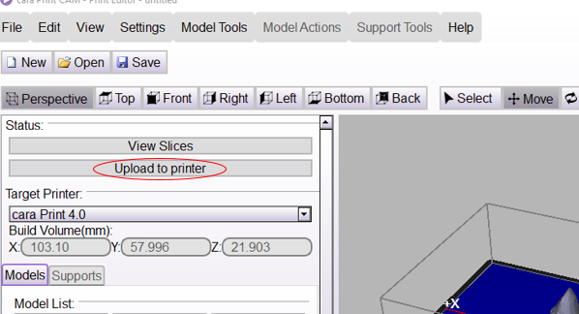

Then choose your printer and click “upload”.

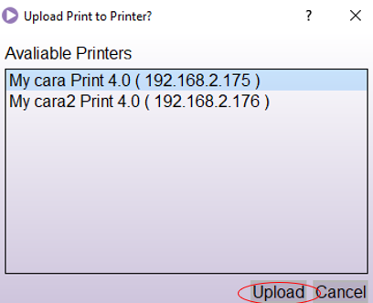

At the printer, start the print per your training.

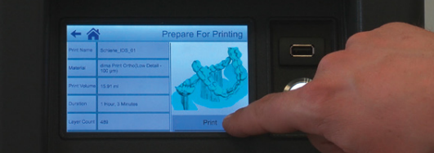

Upon completion of printing process, post process per your training using automated alcohol baths for 3-minute rounds.

Cure in Cara HiLite cure for 5-minute rounds (2 rounds with models flipped in between per training).

If you have questions about anything, stop and ask. Verify proper fit, cleanliness, and final quality of the models prior to allowing any of them to leave the CAM area. All dies go in small baggies with the case number written on the bag.

Section 2

Custom Trays will be completed on the CARAs with dima Print Impression Blue resin and will require changes to the printer’s settings prior to start.

Major differences will be covered in this section with the understanding that you have been previously trained by senior operator.

Be aware that the directory for Trays and Rims will usually be found under the same directory as frames (ManufacturingDir / dima Print Cast) shown below:

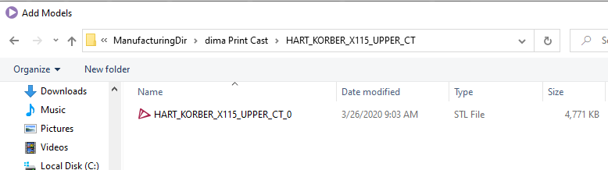

The stl file should be added the same way you would add any model’s file to the print editor. Once your file has been added, you will immediately notice its size will require proper positioning in order to fit on the build plate.

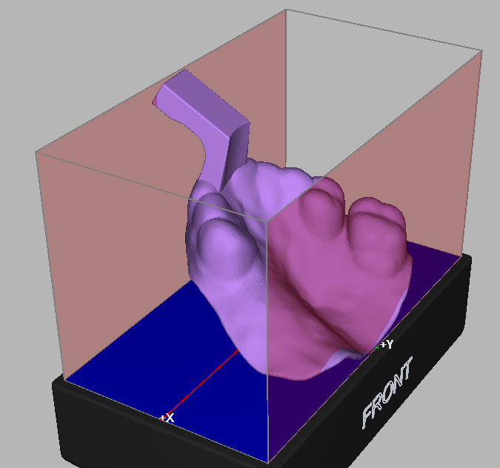

You will also notice that it should be flipped in order to prevent supports from being placed on the portion of the tray that could most likely come in contact with the patient.

The easiest way to do this is to alter the A axis rotation to between 120 degrees and 170 degrees (see image on next page).

This will allow the model to both flip to the correct position and fit on the build plate.

Be aware that manual positioning may be necessary.

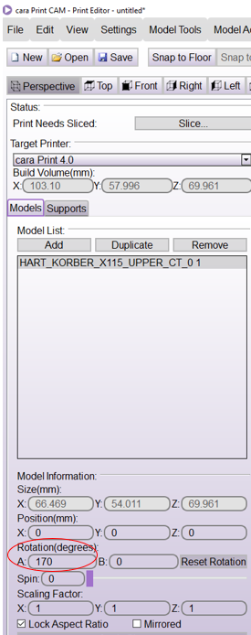

The exact rotation angle depends on multiple variables including, but not limited to, the size of the tray, the angle upon import (design), how many trays are to be printed at once, and other design factors. Proper training and experience will guide this decision.

The result should be as shown below:

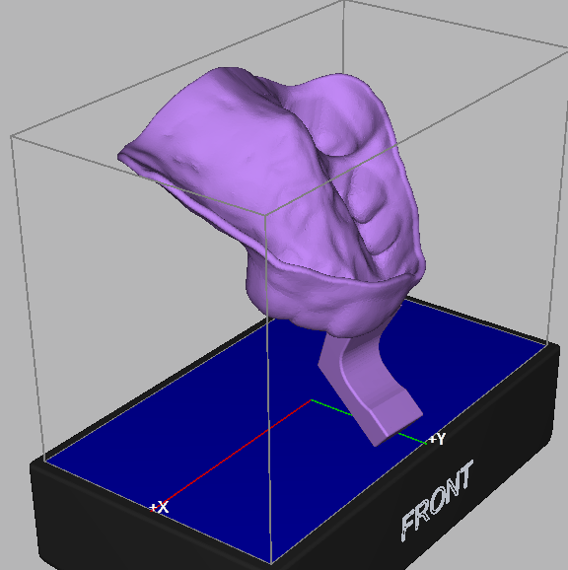

Add supports as with models, but automatic supports should be set between 30% and 40%.

As with model’s SOP, you should remove supports from parts of the tray that could come in contact with the patient and any spurious supports that appear as anomalies.

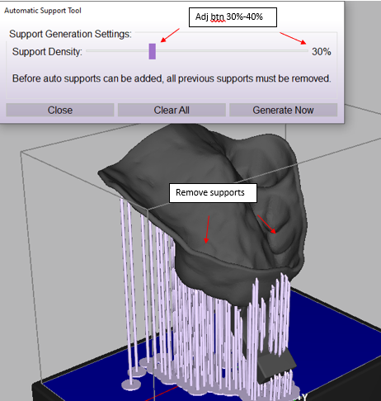

Finally, save per proper protocol, slice, send to printer, change printer settings to dima Print Impression Blue resin, and print your tray.

Post Processing / Cleaning

Arguably, the most important part of 3D printing is the post processing of the printed item and the cleanup that prevents the many opportunities for cross contamination. Our Cara printers have the benefit of having automatic cleaners that allow for consistent results if the SOP is followed. All 3D printing equipment requires that you be trained by a senior operator prior to use. The instructions below are a guide to help previously trained operators “remember” key items when working in the 3D printing lab again after some time away.

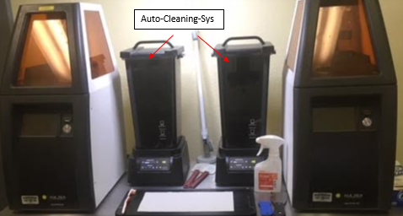

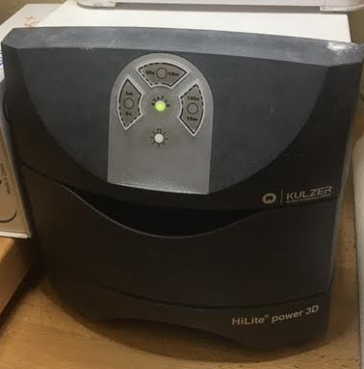

The Kulzer HiLite power 3D will be used for all Cara product.

Here is what Kulzer recommends for each of their resins:

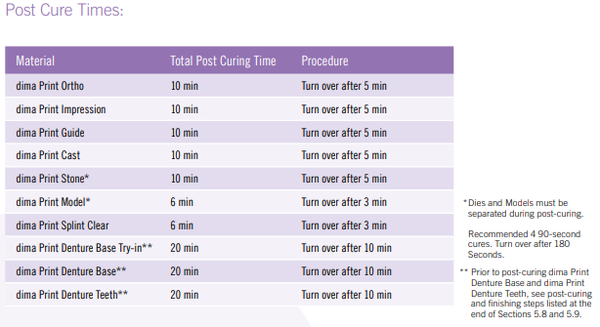

Here is what we currently recommend:

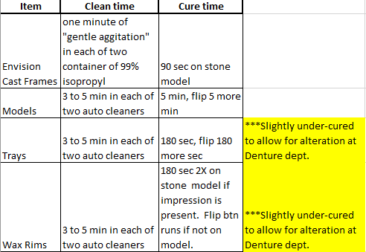

Be aware that our Denture department may alter / augment trays and rims in a variety of ways after we are done. That is why our cure times do not directly match Kulzer documentation. Further, it should be noted that if items are not clean, they could require repeated cleaning cycles.

As always, questions should be directed to senior staff or management.